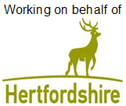


‘Please ensure you have moved your car on the date below’

Surface Dressing Preparation Works in The Street

Between Rosemead and Saint Mary Aspenden Church

Between Thursday 21 October and Monday 25 October
Works between 07:30am and 6:00pm

We are writing to tell you about works we’ll be undertaking in your area.

What you need to do:

- If you need to use your vehicle, please make sure you move it outside the road closure area shown on this letter, at least 30 minutes before we are due to start working.

What you need to know:

- Vehicles may not be allowed access through the road closure during the works, except for emergency vehicles. We are unable to provide information of which part of the road will have access and when. Please speak to the on-site team on the day who will be able to advise on access Leon Zaman 07712 490183 During working hours 09.00 and 5.00pm.

- Where it is safe to do so, the County Council may be able to exercise discretion in exceptional circumstances in order to meet its public sector equality duty.

- Please refer to the yellow signboards on your street to see the exact dates, timings and permit number. Any date changes to these works will be communicated on the yellow signboards at either end of your street and at www.hertfordshire.gov.uk/roadclosures

- These works are weather dependent and may be postponed if poor weather is forecast.

- Details of any disruptions to bus services can be found at www.intalink.org.uk/timetables (search for your service). If you're unable to find this information, please call our customer service centre on 0300 123 4050.

- All local businesses will be open as usual.




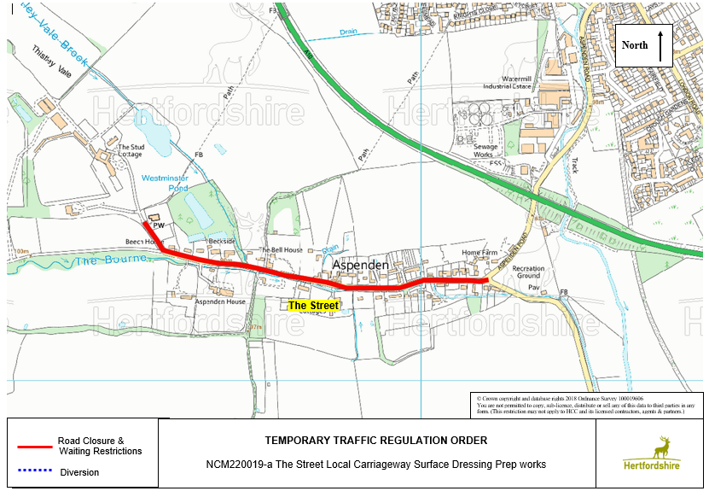
@HertsHighways @HertsHighways @Herts_Highways

Further information:

- The permit number for these works is SDPREP-NCM220019
- If you have any special needs/circumstances that you would like to discuss with the team then please contact Leon Zaman 07712 490183 During working hours 09.00 and 5.00pm or CSCHighways@hertfordshire.gov.uk - By phone on 0300 123 4047.

We understand these works may be an inconvenience to you, however, we ask you to support us as we make the necessary improvements.

For live traffic information and news across Hertfordshire, please follow us on social.

